**BRIGHTWORLD**

**E-PROJECT**

**DOCUMENTATION**

This is to certify that

**MISS. RUKOYAH**

**OJENIYI**

Successfully designed

**BRIGHTWORLD**

**LED LIGHT**

And Submitted.

Date of issue: 14/09/2020

**ACKNOWLEDGMENT**

We would like to express our special thanks and gratitude to our faculty as well as the head of Aptech Ibadan who gave us the opportunity to do this wonderful project on this topic, which also helped us in doing a lot of Research and came to know about so many new thing, we are really grateful to them.

**SYPNOSIS**

Brightworld is an indigenous led light website where you can view and buy led lights of your choice.

We have branches in all over 20 countries which gives us the capacity to deliver goods anywhere within and outside the country. We have 6 months warranty on any product that we sell.

We also sell install-mentally (conditions applied).

**PRODUCTS SOLD**

1. Everready
2. Surya
3. **Everready**

The company completed a century in the dry cell battery market in 2005. That goes on to the show the reliability and quality of its products. And when Eveready decided to step into the LED lighting market, it was welcomed warmly by its faithful customer base. With LED lighting solutions as wide as the Amazon River, the company takes care of both urban and rural needs efficiently.

1. **Surya**

Surya is one of the biggest LED manufacturers in India with 50 different products in the Indian market right now. However, being a forward-facing company, Surya has announced that it will launch 50 more products in the coming years. Surya LED lamps provide the best output along with a long life. More than that, they save up to 90 per cent of energy. The company’s manufacturing plant in NOIDA is one of the most sophisticated in the country.

E Project Design

DFD’s

NETWORKCLIENTS

SERVER

* Enter website address.
* View our home to view some of our top new products.
* We also have warranty schemes for every brands on our website.

**Screenshots**

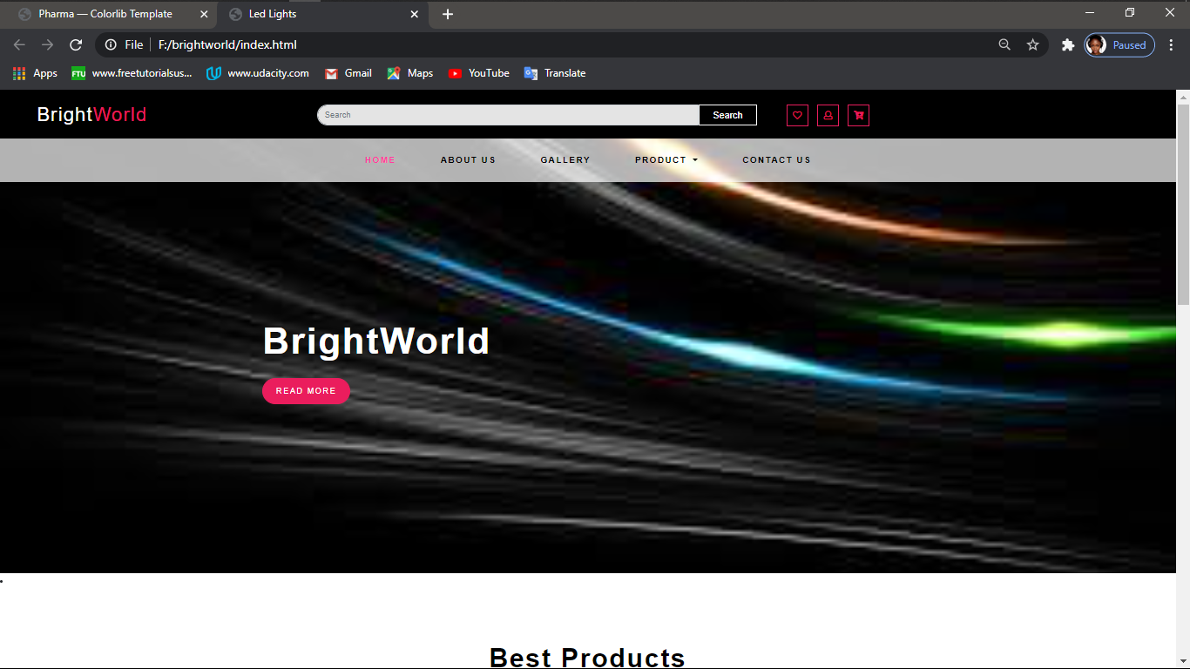

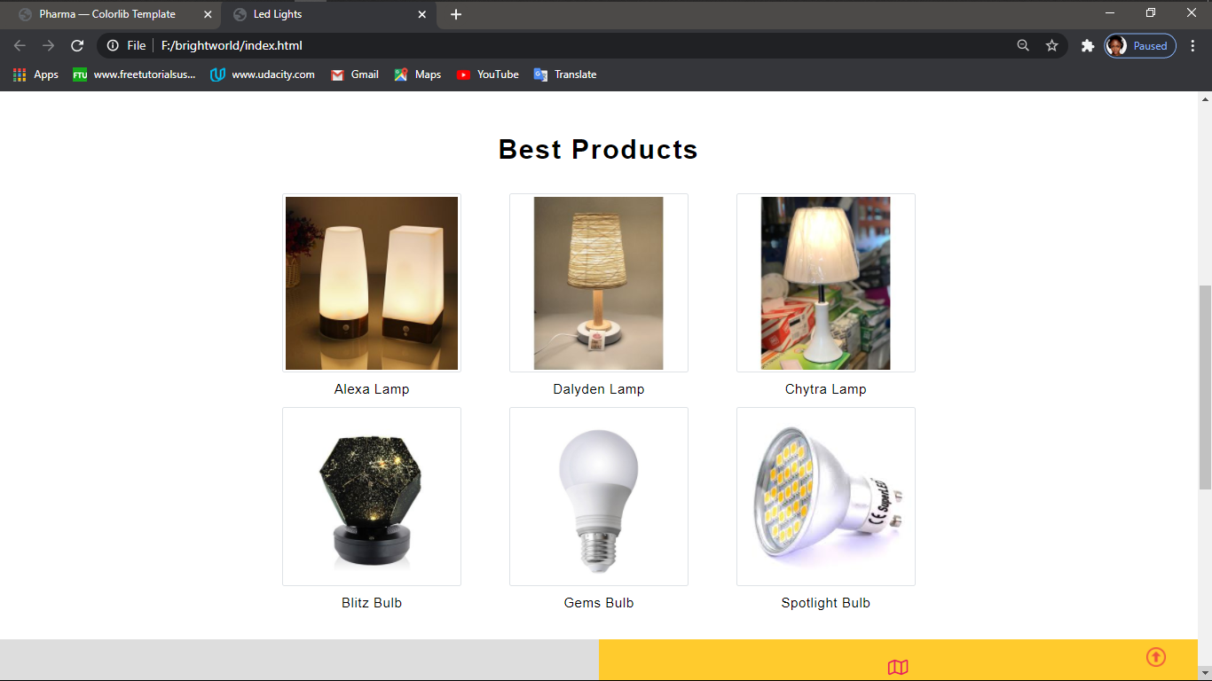

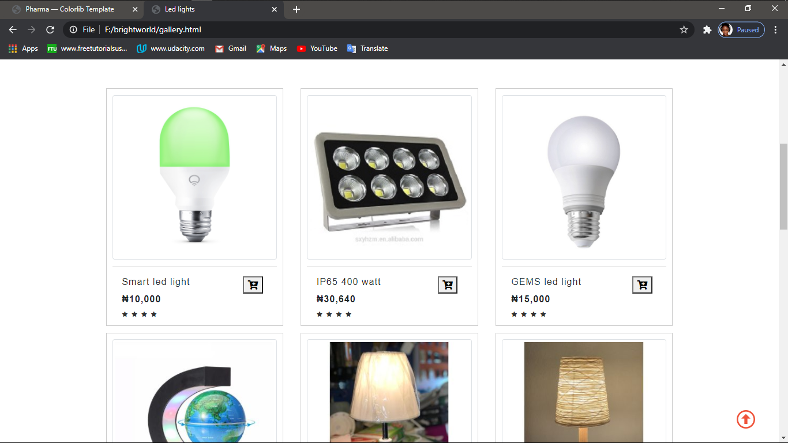

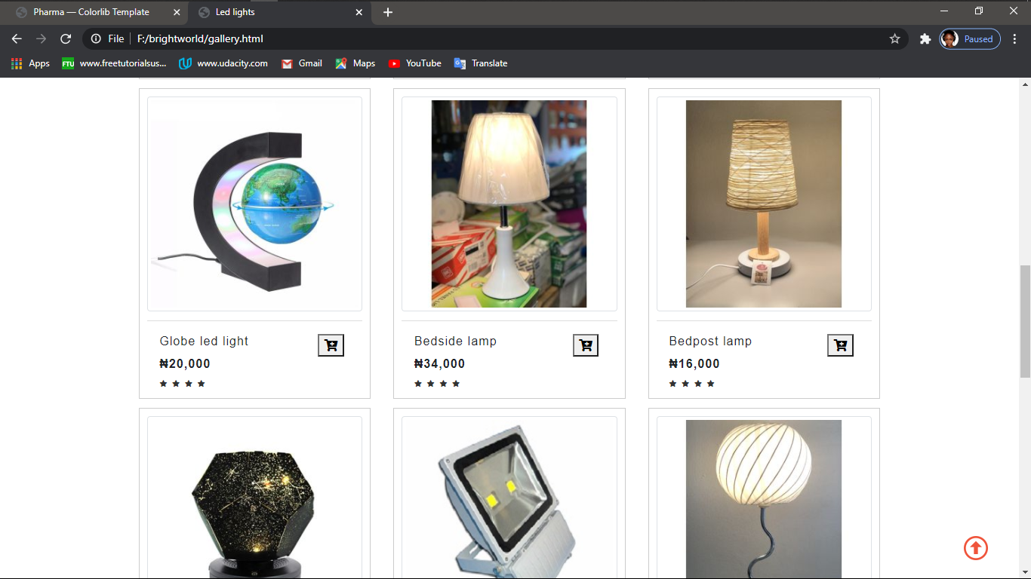

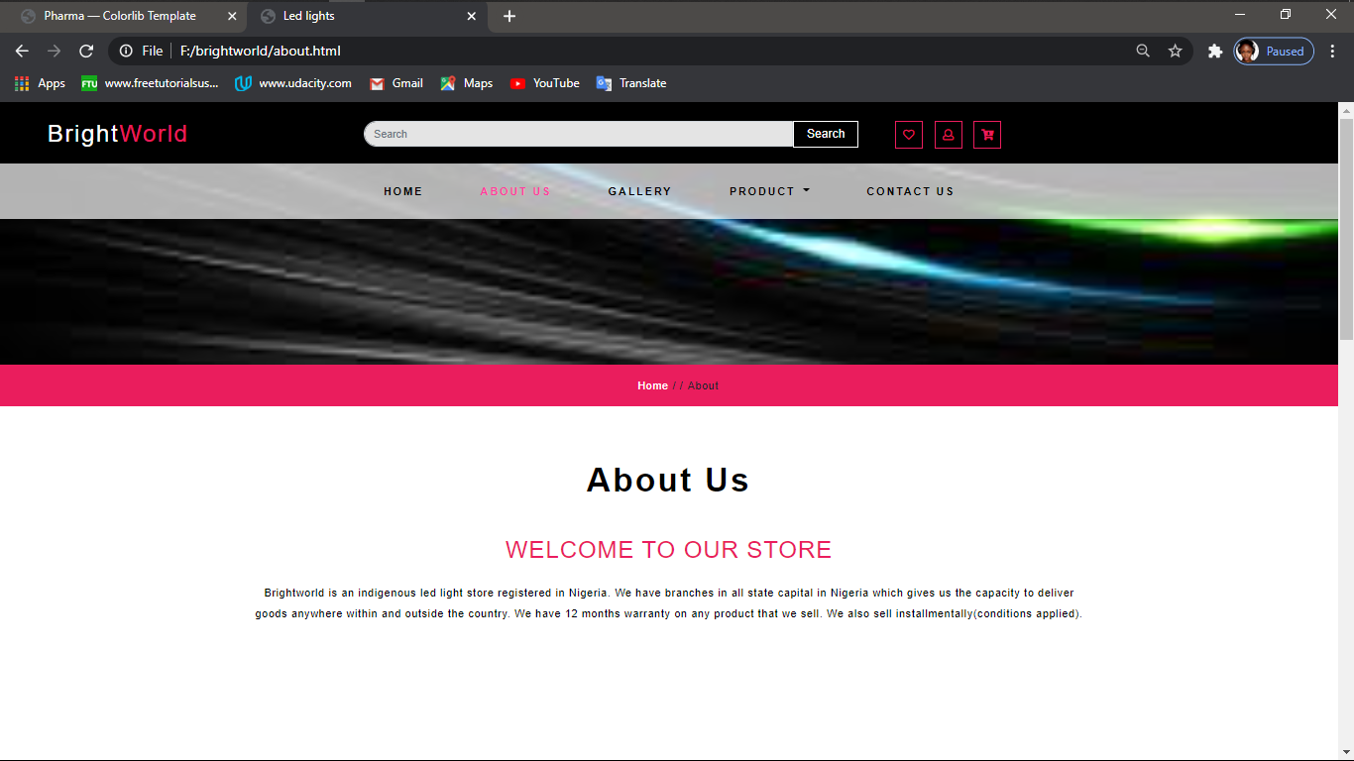

**<link href="css/style.css" rel='stylesheet' type='text/css' media="all">**

**<meta name="viewport" content="width=device-width, initial-scale=1">**

**<meta http-equiv="Content-Type" content="text/html; charset=utf-8" />**

**<script src='js/jquery-2.2.3.min.js'></script>**

**Source code with comments**

<!DOCTYPE html>

<html lang="en">

<head>

<title>Led Lights</title>

<meta name="viewport" content="width=device-width, initial-scale=1">

<meta name="keywords" content="" />

<meta http-equiv="Content-Type" content="text/html; charset=utf-8" />

<script>

addEventListener("load", function () {

setTimeout(hideURLbar, 0);

}, false);

function hideURLbar() {

window.scrollTo(0, 1);

}

</script>

<link href="css/bootstrap.min.css" rel="stylesheet" type="text/css" media="all">

<link href="css/fontawesome-all.min.css" rel="stylesheet" type="text/css" media="all">

<link rel="stylesheet" href="css/flexslider.css" type="text/css" media="all" />

<link href="css/JiSlider.css" rel="stylesheet">

<link rel="stylesheet" href="css/shop.css" type="text/css" />

<link href="css/style.css" rel='stylesheet' type='text/css' media="all">

<link href="//fonts.googleapis.com/css?family=Sunflower:500,700" rel="stylesheet">

<link href="//fonts.googleapis.com/css?family=Open+Sans:400,600,700" rel="stylesheet">

<style type="text/css">

body,td,th {

font-family: Sunflower, sans-serif;

}

body {

background-color: #FFFFFF;

}

</style>

</head>

<body>

<div class="header-outs" id="home">

<div class="header-bar">

<div class="container-fluid">

<div class="hedder-up row">

<div class="col-lg-3 col-md-3 logo-head">

<h1><a class="navbar-brand" href="index.html">Bright<span class="world">World</span></a></h1>

</div>

<div class="col-lg-5 col-md-6 search-right">

<form class="form-inline my-lg-0">

<input class="form-control mr-sm-2" type="search" placeholder="Search">

<button class="btn" type="submit">Search</button>

</form>

</div>

<div class="col-lg-4 col-md-3 right-side-cart">

<div class="cart-icons">

<ul>

<li>

<span class="far fa-heart"></span>

</li>

<li>

<button type="button" data-toggle="modal" data-target="#exampleModal"> <span class="far fa-user"></span></button>

</li>

<li>

<span class="fas fa-cart-arrow-down"></span>

</li>

</ul>

</div>

</div>

</div>

</div> <p <nav class="navbar navbar-expand-lg navbar-light">

<button class="navbar-toggler" type="button" data-toggle="collapse" data-target="#navbarSupportedContent" aria-controls="navbarSupportedContent" aria-expanded="false" aria-label="Toggle navigation">

<span class="navbar-toggler-icon"></span>

</button>

<div class="collapse navbar-collapse justify-content-center" id="navbarSupportedContent">

<ul class="navbar-nav ">

<li class="nav-item active">

<a class="nav-link" href="index.html">Home <span class="sr-only">(current)</span></a>

</li> <p class="title"><h1>2012 Mercedes-Benz G550</h1></p>

<div class="price1" style="height: 19px;">

<span class="reducedfrom">&#8358 18,580,000</span>

</li>

<li class="nav-item">

<a href="about.html" class="nav-link">About us</a>

</li>

<li class="nav-item">

<a href="gallery.html" class="nav-link">Gallery</a>

</li>

<li class="nav-item dropdown">

<a class="nav-link dropdown-toggle" href="#" id="navbarDropdown1" role="button" data-toggle="dropdown" aria-haspopup="true" aria-expanded="false">

Product

</a> <a <div class="dropdown-menu" aria-labelledby="navbarDropdown">

<a class="nav-link" href="product.html">Bulb</a>

<a class="nav-link " href="product2.html">Decoration light</a>

<a class="nav-link " href="product3.html">Smart light</a>

<a class="nav-link " href="product4.html">Spot light</a>

</div>

</li>

<li class="nav-item">

<a href="contact.html" class="nav-link">Contact us</a>

</li>

</ul>

</div>

</nav>

</div> <li>

<div class="slider-img two-img">

<div class="container">

<div class="slider-info ">

<h5>BrightWorld</h5>

<div class="bottom-info">

</div>

<div class="outs_more-buttn">

<a href="about.html">Read More</a>

</div>

</div>

</div>

</div>

</li>

<li>

</li>

<div class="clearfix"></div>

</div>

<section class="about py-lg-4 py-md-3 py-sm-3 py-3" id="about">

<div class="container py-lg-5 py-md-5 py-sm-4 py-4">

<h3 class="title text-center mb-lg-5 mb-md-4 mb-sm-4 mb-3">Best Products</h3>

<div class="row banner-below-w3l">

<div class="col-lg-4 col-md-6 col-sm-6 text-center banner-agile-flowers">

<img src="image/1 (1).jpg" class="img-thumbnail" alt="" height="300" width="300">

<div class="banner-right-icon">

<h4 class="pt-3">Alexa Lamp </h4>

</div> </ul>

</div>

<div class="col-lg-4 col-md-6 col-sm-6 text-center banner-agile-flowers">

<img src="image/1 (6).jpg" class="img-thumbnail" alt="" height="300" width="300">

<div class="banner-right-icon">

<h4 class="pt-3">Dalyden lamp</h4>

</div>

</div>

<div class="col-lg-4 col-md-6 col-sm-6 text-center banner-agile-flowers">

<img src="image/1 (17).jpg" class="img-thumbnail" alt="" height="300" width="300">

<div class="banner-right-icon">

<h4 class="pt-3">Chytra Lamp</h4>

</div>

</div>

<div class="col-lg-4 col-md-6 col-sm-6 mt-3 text-center banner-agile-flowers">

<img src="image/1 (18).jpg" class="img-thumbnail" alt="" height="300" width="300">

<div class="banner-right-icon">

<h4 class="pt-3">Blitz bulb</h4>

</div>

</div>

<div class="col-lg-4 col-md-6 col-sm-6 mt-3 text-center banner-agile-flowers">

<img src="image/downloadfile-1.jpg" class="img-thumbnail" alt="" height="300" width="300">

<div class="banner-right-icon">

<h4 class="pt-3">Gems bulb</h4>

</div>

</div> </li>

<div class="col-lg-4 col-md-6 col-sm-6 mt-3 text-center banner-agile-flowers">

<img src="image/images%20(1).jfif" class="img-thumbnail" alt="" height="300" width="300">

<div class="banner-right-icon">

<h4 class="pt-3">Spotlight bulb</h4>

</div>

</div>

</div>

</div> <span> <a <section class="subscribe">

<div class="container-fluid">

<div class="row">

<div class="col-lg-6 col-md-6 map-info-right px-0">

<!-- location map-->

<iframe src="https://www.google.com/maps/embed?pb=!1m18!1m12!1m3!1d3956.5696008506948!2d3.887811114152991!3d7.4020257143815265!2m3!1f0!2f0!3f0!3m2!1i1024!2i768!4f13.1!3m3!1m2!1s0x10398d419dbaa57d%3A0xf45932e7e979aba6!2sMokola%20ibadan%20Temidire!5e0!3m2!1sen!2sng!4v1602159717469!5m2!1sen!2sng" width="600" height="450" frameborder="0" style="border:0;" allowfullscreen="" aria-hidden="false" tabindex="0"></iframe>

</div>

<div class="col-lg-6 col-md-6 address-w3l-right text-center">

<div class="address-gried ">

<span class="far fa-map"></span>

<p>Mokola Temidire Ibadan

<p>

</div>

<div class="address-gried mt-3">

<span class="fas fa-phone-volume"></span>

<p> 09023456789<br>08045687621</p>

</div>

<div class=" address-gried mt-3">

<span class="far fa-envelope"></span>

<p><a href="mailto:info@example.com">brightworld2020@gmail.com</a>

</p>

</div>

</div>

</div>

</div>

</section>

<!--//subscribe-address-->

<section class="sub-below-address py-lg-4 py-md-3 py-sm-3 py-3">

<div class="container py-lg-5 py-md-5 py-sm-4 py-3">

<h3 class="title clr text-center mb-lg-5 mb-md-4 mb-sm-4 mb-3">Get In Touch Us</h3>

<p class="my-3"><center>For more information contact us on our social media platform <br>

<a href="#"><span class="fab fa-facebook"></span></a>&nbsp;&nbsp;BrightWorld On facebook<br>

<a href="#">&nbsp;&nbsp;&nbsp;<span class="fab fa-instagram"></span></a>&nbsp;&nbsp;&nbsp;Bright_World on Instagram</center>

</p>

<div class="email-sub-agile">

<form action="#" method="post">

<div class="form-group sub-info-mail">

<input type="email" class="form-control email-sub-agile" placeholder="Email">

</div>

<div class="text-center">

<button type="submit" class="btn subscrib-btnn">Subscribe</button>

</div>

</form>

</div>

</div>

</section>

<!--//subscribe-->

<!-- footer -->

<footer class="py-lg-22 py-lg-40 py-lg-33 py-3 text-center">

<div class="copy-agile-right">

<p>

© 2020 Brightworld All Rights Reserved | Design by Romaty

</p>

</div>

</footer>

</section>

<script src='js/jquery-2.2.3.min.js'></script>

<script src="js/minicart.js"></script>

<script>

toys.render();

toys.cart.on('toys_checkout', function (evt) {

var items, len, i;

if (this.subtotal() > 0) {

items = this.items();

for (i = 0, len = items.length; i < len; i++) {}

}

});

</script>

<script src="js/responsiveslides.min.js"></script>

<script>

$(function () {

$("#slider4").responsiveSlides({

auto: true,

pager:false,

nav:true ,

speed: 900,

namespace: "callbacks",

before: function () {

$('.events').append("<li>before event fired.</li>");

},

after: function () {

$('.events').append("<li>after event fired.</li>");

}

});

});

</script>

<script src="js/jquery.flexisel.js"></script>

<script>

$(window).load(function() {

$("#flexiselDemo1").flexisel({

visibleItems: 3,

animationSpeed: 3000,

autoPlay:true,

autoPlaySpeed: 2000,

pauseOnHover: true,

enableResponsiveBreakpoints: true,

responsiveBreakpoints: {

portrait: {

changePoint:480,

visibleItems: 1

},

landscape: {

changePoint:640,

visibleItems:2

},

tablet: {

changePoint:768,

visibleItems: 2

}

}

});

});

</script>

<script src="js/move-top.js"></script>

<script src="js/easing.js"></script>

<script>

jQuery(document).ready(function ($) {

$(".scroll").click(function (event) {

event.preventDefault();

$('html,body').animate({

scrollTop: $(this.hash).offset().top

}, 900);

});

});

</script>

<script>

$(document).ready(function () {

var defaults = {

containerID: 'toTop', // fading element id

containerHoverID: 'toTopHover', // fading element hover id

scrollSpeed: 1200,

easingType: 'linear'

};

$().UItoTop({

easingType: 'easeOutQuart'

});

});

</script>

<script src="js/bootstrap.min.js"></script>

</body>

</html>

**Users guide**

This website is like every regular ecommerce website that you use on a daily basis, it is easily accessible and you just have to use your mouse to navigate through the website and it takes you to the page that you want to.

This website can be used on any web browser e.g. Chrome, Firefox, etc.

**Developer’s guide**

Html 5 is the latest evolution of the standard that defines Html. It is a new version of the Html, with new element, attributes, and behavior, and a large set of technologies that allows the building of more diverse and powerful websites.

This website was styled using Html5, CSS, BootStrap, Javascript designed to be useable by all Open Web developers.